Dear Sir

Attached for your information and review is my resume outlining my education and experience for the purpose of obtaining an employment in your firm.

Please review my resume as it relates to your needs now or in the future and contact me at your earliest convenience. I am readily available for a personal interview to discuss employment possibilities.

I am confident about my technical approaches and therefore, I wish that you would consider my application for the applied post. Please inform me about the interview details on the above-mentioned contact details as per your convenience. I wish to meet you in person for further discussion regarding the job responsibilities.

Sincerely,

Hatem Salah

**0795462856**

[Hatemsalah23@hotmail.com](mailto:Hatemsalah23@hotmail.com)

https://www.hatemalkhatib.com

**CURRICULUM VITAE**

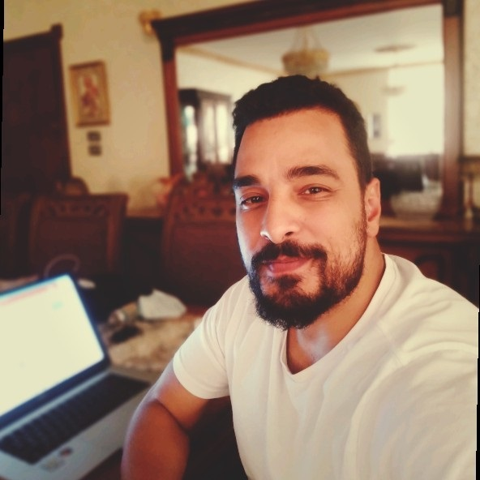

**PERSONAL DETAILS:**

**Name:** Hatem Salah Khatib **Nationality:** Jordanian

**address:** Amman Jordan **Marital Status:** Married

**Date of Birth:** 26.06.1984

**Telephone:** 0795462856 **Email:** hatemsalah23@hotmail.com

**Website :**  www. hatemalkhatib.com

**EDUCATION AND QUALIFICATIONS:**

**2006-2007 ADOBE AND GOOGLE (UAE-SAUDIARABIA)**

Diploma in Fine Art Animation and Web Development

**2002-2006 Al-Zaytoonah University- Jordan**

B.SC Degree in Computer Science

**2002 Islamic College School, Amman**

Scientific - Tawjihi

**WORK EXPERIENCE:**

**2016-2022 Digital Marketing Director**

**LeadersCenter(Jordan )**

* **Build** the digital marketing roadmap
* **Manage** all digital marketing channels (e.g. website, blogs, emails and social media) to ensure brand consistency
* Measure **ROI** and **KPIs** and prepare budget
* Manage and improve online **content**, considering **SEO** and Google **Analytics**
* **Work** with digital marketing **team** to achieve goals.
* in **2017** Monthly traffic for website was **Zero**. In **2021** More than **250k/Month** , around **40%** comes from **SEO** Organic search.
* in **2017** Website income was **Zero$**. In **2021** income around **100k$/Month** , around **30k$** from **SEO** Organic search.
* Work with 3rd party company to make an **APP** on IOS & ANDROID for company with **low budget**.
* Most of Right **keywords** (Easy and Difficult) ranking **#1** on Google.

**2020-Till Now Digital Trainer and Monitor (Coding and Design)**

**(PART-TIME)**

**Digital Opportunity Trust (DOT) /UNICEF (JORDAN)**

**Certified** trainer in the following fields:

* **WordPress** and Web Development.
* **Python**
* **Digital Marketing** and **Graphic Design**.

trained more than 400 students in the years between 2020 till now all over Jordan.

**2016-2018 Computer & EMarketing Instructor (PART-TIME)**

**Petra University (JORDAN)**

**Courses:**

* **Web Design** (HTML5 , CSS3 AND JQUYERY)
* **Web Development** (PHP & CMS System)
* **GameDesign** (Unity & ADOBE FLASH(ANIMATE)
* **Motion Graphic** (Adobe After Effect and Flash)
* **Graphic Design**(Photoshop, Illustrator and Indesign)
* **SEO** Search Engine Optimization
* Digital Marketing Campaign

**2012-2016 Director of Web and Digital Strategy**

**SSC(Saudi Arabia)**

* Develop and implement **SEO strategies** to improve organic search traffic
* **Monitor** website **analytics** and user feedback to identify areas for improvement and make recommendations for changes
* **Collaborate** with Information Technology Services as part of a Web Team to manage the online presence.
* **Works** with the director of marketing to integrate print materials and the website to communicate the brand. Provides direction to the graphic design team for graphics related to website development.
* Generate monthly **reports** on website traffic, conversions, and other key metrics.
* **Manage** web development projects from start to finish, including **QA** testing and launch.

**2008-2012 Web Developer and Digital Marketing Specialist**

**NewsGroup(Dubai)**

* Building and executing **Social Media Strategy** through competitive and audience research
* Create **Graphics** for product illustrations, logos, and websites
* Building natural **Backlinks**, Creating effective ranking strategies
* Working on **Ecommerce** Platforms like: Shopify, WooCommerce, and Magento.
* Create **website** layout/user interface by using standard **HTML5, CSS3** and JavaScript library- **jQuery**.

**2016-Till Now** Owner of one of the biggest jobs page on **facebook** in Jordan have more than **250k** fans and have a **website** called **tawzeefjo.com** have more than **500k** visitors Montly .

**SKILLS:**

**Programing Skills:** HTML5,CSS3,JQUERY,PHP,MYSQLAJAX,AngularJs

**Design Skills:** PHOTOSHOP CC,INDESIGN CC ,ILLUSTRATOR.

**Marketing Skills:** SEO, SEM

**Motion Skills:** Adobe Aftereffect. Adobe Primmer Cinema4D, Adobe Animate

**Office**: WORD, EXCEL, POWERPOINT, FRONTPAGE,ACCESS, (ICDL)

**Project Management System (PMP)**

**Languages:** Arabic

English

**Some of My Work** :

* http://www.newsgroupholding.com/
* http://www.social-eyez.com/
* http://www.mediaeyeme.com/Pages/Public/Home.aspx
* http://www.alpencapital.com/
* www.dolphinenergy.com
* http://www.paneast.com.jo/
* http://daralarqamforhousing.com/
* http://www.saudiservices.com.sa/
* <http://faihagroup.com/>
* www.fsscit.com/
* http://estsharidental.com/
* www.drhishamalkhatib.com/
* http://khatmahfactory.com/
* Posters ,Flyer and Logos for BaredWared, Habtoor, ULC.( More Than 1000 Items)

**Sporting Interests:** Outdoor Activities including mountain walking and skiing.

**Hobbies:** Reading, drawing, playing chess, swimming.